PRESS RELEASE:
November 27, 2006

FOR IMMEDIATE RELEASE:

The Brandywine High School Class of 1967 to celebrate 40th Reunion at newly renovated Blue Ball Dairy Barn in Wilmington, October of 2007.
The Brandywine High School Class of 1967 40th reunion committee have announced that they will celebrate their 40th reunion, Saturday, October 6th 2007 at the newly restored Blue Ball Dairy Barn on Route 202 in Wilmington, Delaware.
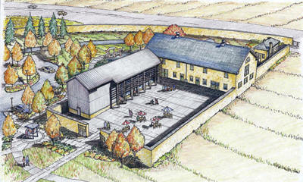
Class of ’67 committee member, Marilyn Monson Nimtz
explained “what better known and more nostalgic place for the Class of ’67 to hold their 40th reunion.” The Blue Ball Properties Project envisions special exhibit spaces dedicated to the Delaware Folk Art Collection and the agricultural history of the Blue Ball Properties and reflects the rural background of the area. A new addition will provide visitor services catering facilities and an elevator, which will permit easy access to all areas of the barn.

The Brandywine High School Class of 1967 40th Reunion Committee is a volunteer organization made of the following individuals:

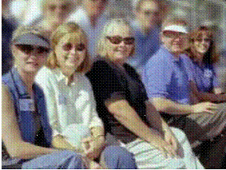
Sherry Chapman Grizzel, Hockessin, DE scgrizzel@aol.com 302-239-7485
Linda Fuhrmeister Potter, Tampa, FL lpotter@tampabay.rr.com 727-864-2581
Pat Walker Fox, Winchester, VA XOFTAP@aol.com 540-539-4950
Kevin Donohue, Ellicott City, MD donohue11@comcast.net 410-884-4220
Marilyn Monson Nimtz, Hockessin, DE mnimtz@svglaw.com 302-239-2131

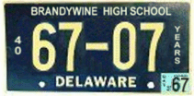
There were originally 547 graduating members of the Brandywine High School of 1967. If you are a member of the BHS Class of 1967 or know the whereabouts of members of the class of ‘67, you may contact the reunion committee individuals at the information listed above. You may also access information about individuals and teachers who made up the BHS Class of 1967 and find additional 40th reunion information at the Class of 1967’s website at www.kevin67.com.

