Remember A Time When Music Lyrics Had Really Deep Meaning?
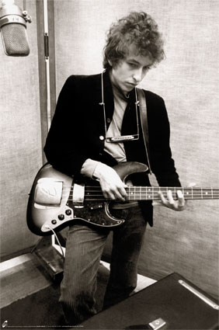

Yeah, you got that somethin'
I think you'll understand

Ooh, I bet you're wond'rin' how I knew
'bout your plans to make me blue

Then I saw her face
Now I'm a believer

Jumped out of bed
Turned on the light
I pulled down the shade
Went to the kitchen for a bite

There’s a crazy little shack beyond the tracks
And ev’rybody calls it the sugar shack

(Why don't you come out) (come out) to my twist party (Come out) Where the bright moon shines
Big girls don't cry
Big girls don't cry

When I was younger, so much younger than today,
I never needed anybody's help in any way.

Dum-dum-dum-dumdy-doo-wah
Ooh-yay-yay-yay-yeah
Oh-oh-oh-oh-wah
Only the lonely
When I'm drivin' in my car, and the man come on the radio
He's tellin' me more and more about some useless information
Supposed to fire my imagination
One of these days these boots are gonna walk all over you

You can hear these lyrics and a lot more just like these by attending the

Brandywine High School
Class of 1967 40th Reunion,
Saturday, October 6th, 2007
at the Blue Ball Dairy Barn
in Wilmington, Delaware
PS..Only 30 days till the reunion. Catering deadline is 9.23. Don't forget to get your $65 reunion check in the mail ASAP to our reunion treasurer: Marilyn Monson Nimtz!
Check www.kevin67.com to see who's said "yes," "no," or "maybe." to attending the reunion - WOW!! 90 classmates have already sent in their checks as of (9.6.07).

