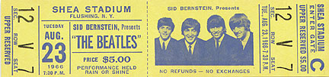
Score The Hottest Ticket In Town:
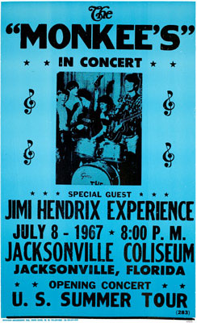
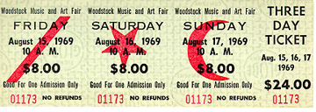
Maybe you missed Woodstock but you definitely don’t want to miss the Brandywine High School Class of 1967 40th Reunion, Saturday, October 6th, 2007 at the Blue Ball Dairy Barn in Wilmington Delaware.
Reserve your ticket now at www.kevin67.com
