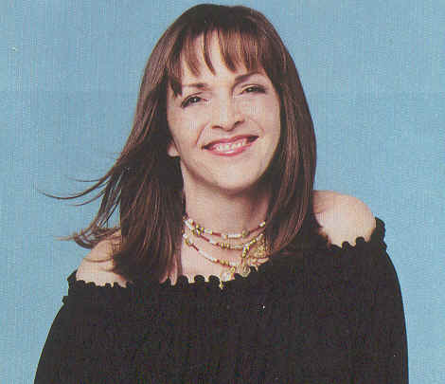
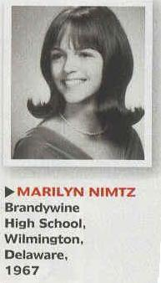
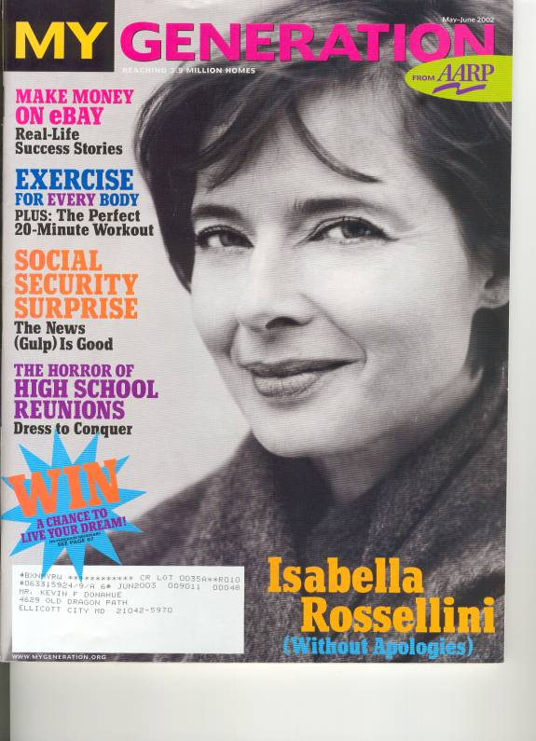

“I’d like to look more artsy and funky for my reunion. I work in a law office and wear a suit to work so I’d like to look more relaxed. People make assumptions based on what you look like. I want to present a relaxed picture. I have tried to maintain a youthful attitude and approach to life. I was friendly with people from a variety of groups. I hope to see all of them at our upcoming reunion."

