On the road of life, the last four decades may have found us tilting at a windmill or two.

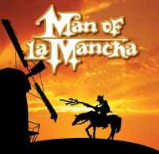
But on October 6th, 2007, join the BHS Class of ‘67 for a party at the restored Blue Ball Dairy Barn (alas no windmill) in Wilmington. A party even Don Quixote would enjoy.

Our mission: to reconnect, laugh until our cheeks hurt and realize just where our dreams, impossible or not, have taken us.
To find out more details, find out who’s attending
& to sign up yourself, just click on: www.kevin67.com
