Re-Discover Your Inner Teen

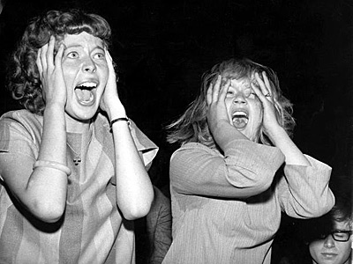
Attend the BHS Class of 1967 40th Reunion at the Blue Ball Dairy Barn, October 6th, 2007.

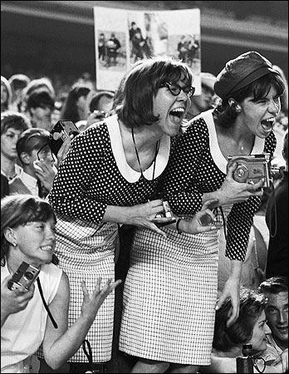
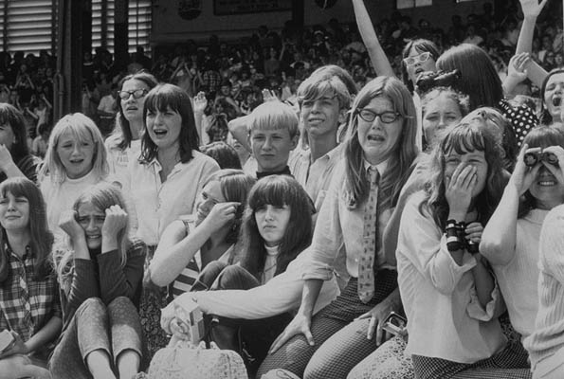
For more information, guest lists and to sign up just click on www.kevin67.com

